


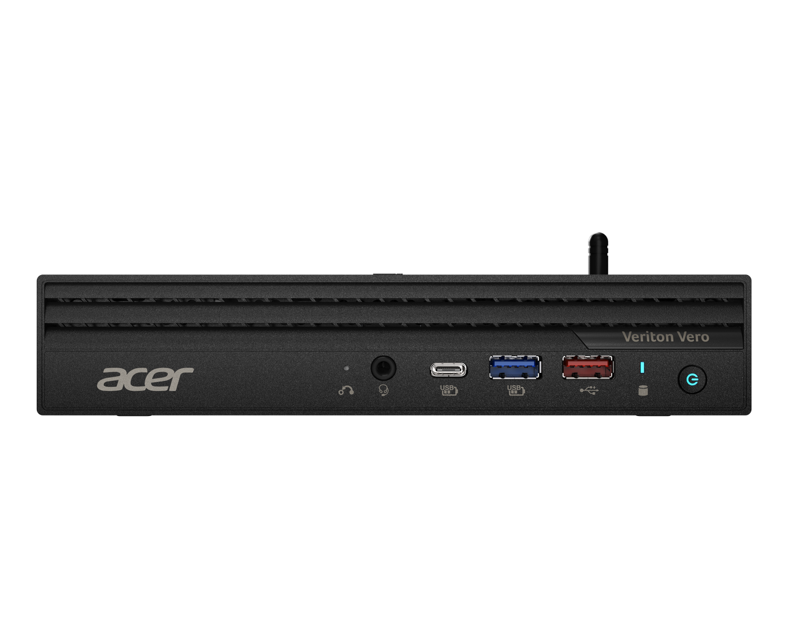

Veriton Vero 4000 Mini
Veriton Vero 6000 Mini

SPECIFICATIONS Acer TravelMate P2 16 TMP216-42 | TMP216-42-TCO
Acer NITRO V 16S ANV16S-71

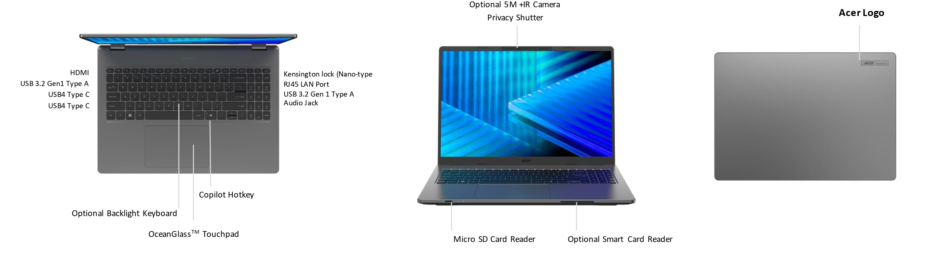
Operating System |  | Windows 11 Pro (Acer recommends Windows 11 Pro for business.)  Windows 11 Home
CPU and Chipset |  | AMD Ryzen™ 7 PRO 250  AMD Ryzen™ 5 PRO 230
Memory |  | Dual-channel DDR5 SDRAM support | Memory Frequency: Up to 5600 MT/s |  | Up to 32 GB of DDR5 system memory using two soDIMM modules
Display |  | 16.0" display with IPS (In-Plane Switching) technology | WUXGA 1920 x 1200 | Acer ComfyView™ LED-backlit TFT LCD | 120 Hz refresh rate  - 16:10 aspect ratio  - 100% sRGB color gamut  - Wide viewing angle up to 170 degrees  - Mercury free, environment friendly |  |  |  | 16.0" display with IPS (In-Plane Switching) technology | WUXGA 1920 x 1200 | Acer ComfyView™ LED-backlit TFT LCD | 120 Hz refresh rate  - 16:10 aspect ratio  - 45% NTSC color gamut  - Wide viewing angle up to 170 degrees  - Mercury free, environment friendly
Graphics |  | AMD Radeon™ 780M Graphics  Graphics Special Technology:  •VP9, H.264, H.265 8bit/10bit decode  • H.264, H.265 8bit video encode | AMD Radeon™ 760M Graphics  Graphics Special Technology:  •VP9, H.264, H.265 8bit/10bit decode  • H.264, H.265 8bit video encode
Audio |  | DTS® Audio, featuring optimized bass response and micro-speaker distortion prevention  Acer TrueHarmony Technology for lower distortion, wider frequency range, headphone-like audio and powerful sound by Acer Ultra Boost Stereo Speaker Module  Compatible with Cortana with Voice |  |  | Acer Purified.Voice technology with AI noise reduction with dual-mic array built-in microphones. Features include far-field pickup, dynamic noise reduction through neural network, adaptive beam forming, and pre-defined personal and conference call modes.  High SNR DAC with 2.1 Vrms out capability and can driver high impedance headphone (up to 600 ohm)
Storage |  | Solid state drive (2 slot): 256 GB / 512 GB / 1 TB, PCIe Gen4, 16 Gb/s, NVMe
Webcam |  | Windows configuration  UFC with double T-type USB 5 MP and IR camera | 2880 x 1800 resolution | 1800p 5 MP video at 30 fps with temporal noise reduction | Staggered high dynamic range (SHDR) | IR 940 nm | Blue glass lens | Dual microphones 33 mm + 33 mm | 86 x 3.2 (4.2) x 3 mm | Windows compatible only  Chromebook configuration  UFC with USB FHD camera | 1920 x 1080 resolution | 1080p video with temporal noise reduction | Blue glass lens | Dual microphones 33 mm + 33 mm | 86 x 3.2 (4.2) x 3 mm | Chromebook compatible only
Wireless and Networking |  | WLAN:  •Wi-Fi 7 Wireless LAN  •802.11 a/b/g/n/ac/ax/be  •Band: 2.4 GHz, 5 GHz, and 6 GHz  •2x2 MU-MIMO technology  •GT Booster - AI Flow | LAN:  • Gigabit Ethernet, Wake-on-LAN ready  WPAN:  •Supports Bluetooth® 5.4 or above for Wi-Fi 7 wireless card.  •Supports Bluetooth LE Audio (LC3).
Security |  | Acer ProShield Plus security manager includes: Data protection: File and folder encryption and decryption, Personal Security Drive | Data removal: File shredding | Security alert: Invalid access alert, Security report  Discrete Trusted Platform Module (TPM) solution | Kensington lock (Nano-type) | Camera shutter | BIOS passwords: User, Supervisor, HDD (OPAL)
Dimensions and Weight |  | Dimensions  357.58 (W) x 252.97 (D) x 19.3/20.8 (H) mm (14.08 x 9.96 x 0.76/0.82 inches) with LAN port |  |  | Weight  1.641 kg (3.62 lbs.) with 3-cell battery pack, one SSD
Power Adapter and Battery |  | Power Adapter  •100 W PD PCR 50%, TCO 10.0 AC adapter  •5 V / 3 A or 9 V / 3 A or 12 V / 3 A or 15 V / 3 A or 20 V / 5 A as output power  •108.0 (W) x 56.0 (D) x 26.5 (H) mm  •296 g ± 5% with 150 cm DC cable  •Black color with Acer logo  •Brick type AC pins  •Paper sleeve packaging |  | •65 W PD PCR 50%, TCO 10.0 AC adapter  •5 V / 3 A or 9 V / 3 A or 12 V / 3 A or 15 V / 3 A or 20 V / 3.25 A as output power  •90.0 (W) x 51.0 (D) x 28.5 (H) mm  •192g ± 10% with 150 cm DC cable  •Black color with Acer logo  •Brick type AC pins  •Paper sleeve packaging |  | Battery  •53 Wh 3-cell Li-ion battery  •Supports Fast Charging technology  •For models with WUXGA Panel + SSD  Battery life:  •Up to 8 hours (based on MobileMark® 2030 test results) | •65 Wh 3-cell Li-ion battery  •Supports Fast Charging technology  •For models with WUXGA Panel + SSD  Battery life:  •Up to 10 hours (based on MobileMark® 2030 test results)
Input and Control |  | Keyboard  99 / 100 / 103 keys | Acer keyboard layout | International language support  Caps Lock indicator  F4 microphone mute indicator  99 / 100 / 103 keys | Acer backlit keyboard | International language support  Caps Lock indicator  F4 microphone mute indicator  Spill-resistant keyboard | MIL-STD-810H Method 506.6 Procedure III drip test |  |  |  | Touchpad  OceanGlass™ touchpad | Multi-gesture support | Two-finger scroll | Pinch gesture | Gestures to open Cortana | Action Center | Multitasking | Application commands  Windows Hello certification | Control keys  Microsoft Copilot key  TravelMate Sense key
Windows Desktop Apps |  | In-House Applications  Acer LiveArt | Acer ORD Service | Acer QuickPanel | TravelMate Sense |  |  | Tools  Acer My Key Application
System Compliance |  | ENERGY STAR® | Wi-Fi® | TCO Certified (TMP216-42-TCO) | EPEAT® registered
Warranty |  | One-year International Travelers Warranty (ITW)
Disclaimers
• | Specifications vary depending on model.
• | Shared system memory may be allocated to support graphics, depending on system memory size and other factors. Actual system memory available to the operating system will be reduced by any memory used by the graphics solution and resources required by the operating environment.
• | Memory speed may vary, depending on the CPU, chipset or memory fitted.
• | All brands and product names mentioned herein include trademarks of their respective companies and are used solely to describe or identify the products.
• | 1 GB is 1 billion bytes. Actual formatted capacity is less and may vary depending on preloaded materials and operating environment. Acer Recovery Management uses a portion of the stated hard disk capacity as dedicated backup space.
• | Minor variations in system dimensions are possible due to the manufacturing process.
• | Weight may vary depending on product configuration, vendor components, manufacturing variability, and selected options.
• | The listed battery life is tested by Power Qualification Test v2 for ChromeOS: 1) Browsing: This test collects power data while browsing(scrolling up & down) cached sites in public Google Cloud Storage. 2) VideoPlayback: This test plays offline video in fullscreen from ramdisk repeatedly for 6 mins / 1 hour.
• | Actual battery life may vary considerably by specifications, depending on product model, configuration, applications, power management settings, operating conditions, and features utilized. Performance variation also arises based on components in use, which includes but is not limited to the processor, RAM capacity, storage, display and resolution, etc.
•
• | Bundled software may vary depending on hardware configuration, OS and regional availability.
• | EPEAT® registration varies by country. See http://www.epeat.net/ for registration status for each country.

Product Sheet is based on TravelMate P216-42 Specifications (v1-0-0) (Preview)

